<https://learn.saylor.org/pluginfile.php/1/tool_certificate/issues/1760169324/2149750882AL.pdf>

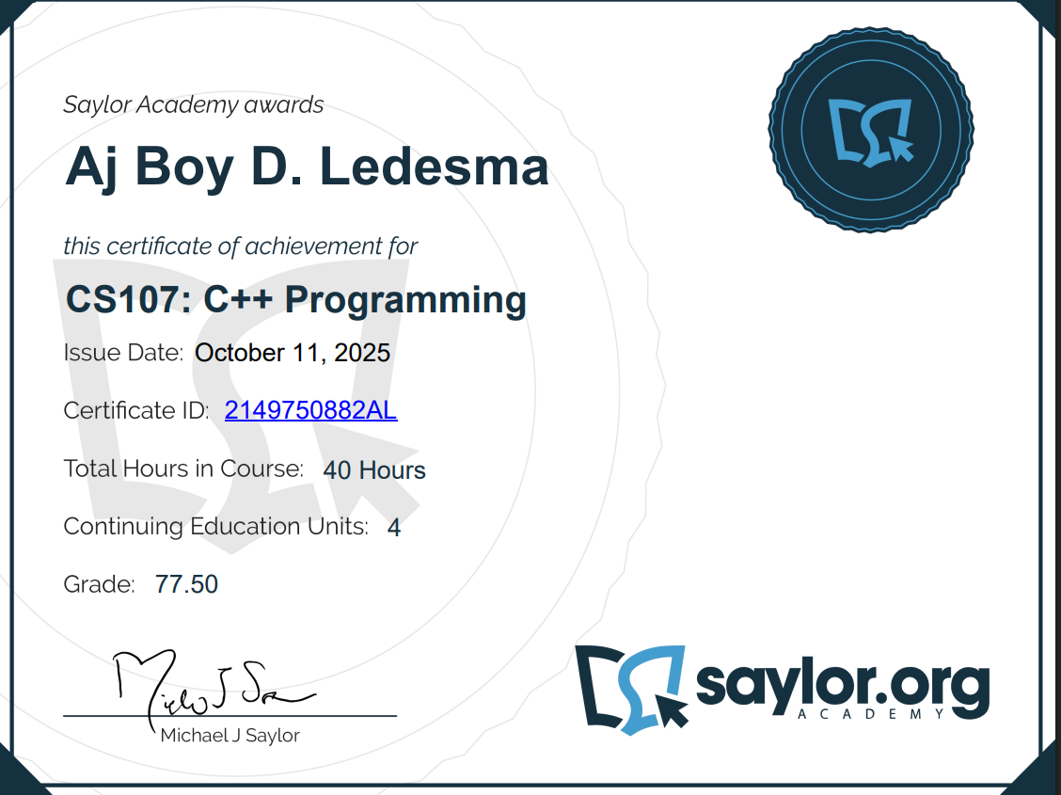

<https://learn.saylor.org/pluginfile.php/1/tool_certificate/issues/1760172028/9249885583AL.pdf>

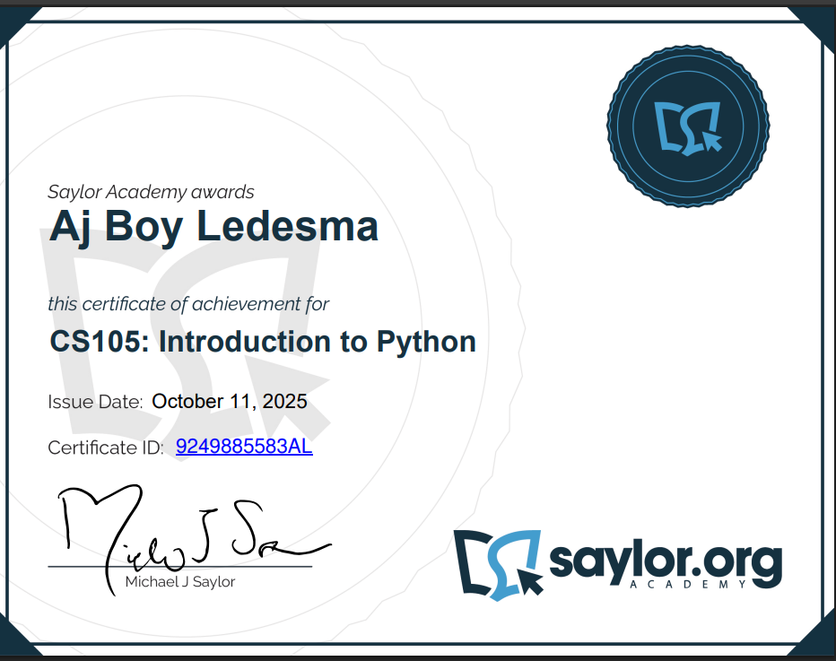

<https://www.freecodecamp.org/certification/fcc-ff88e19c-f6bc-4d54-81b9-cecfd664c9a2/responsive-web-design>

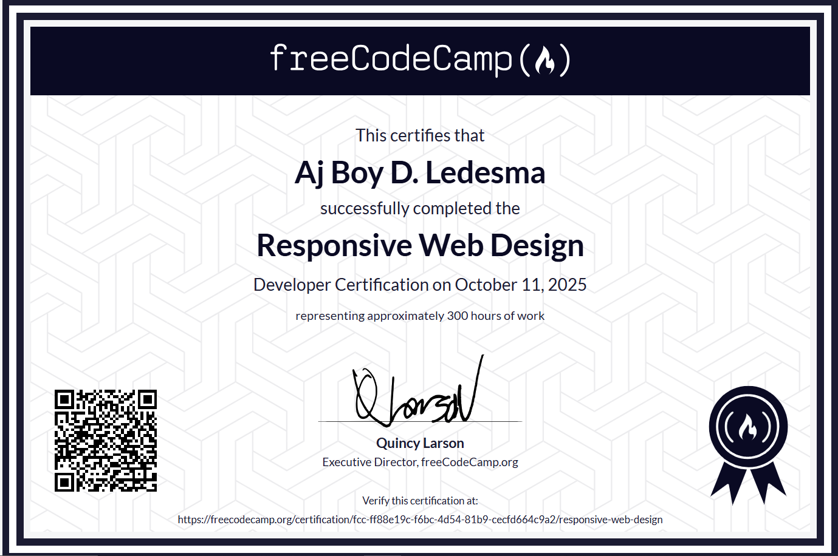

<https://learn.saylor.org/pluginfile.php/1/tool_certificate/issues/1760285181/8178771018AL.pdf>

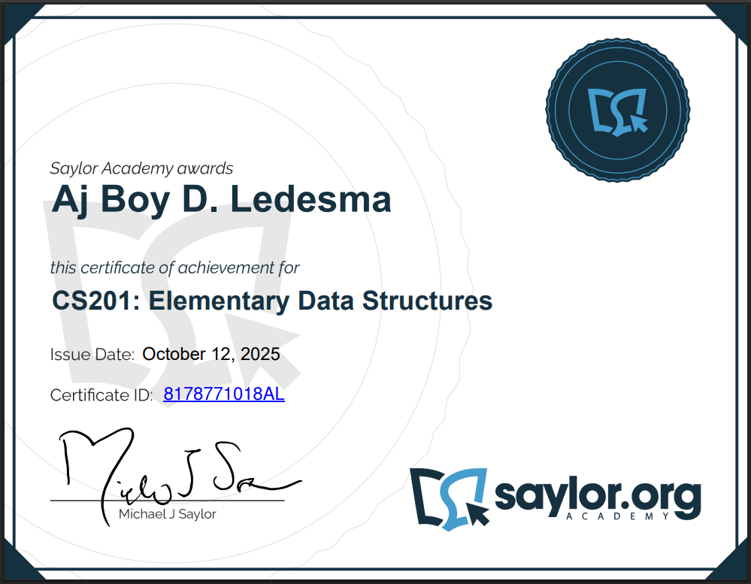

<https://learn.saylor.org/pluginfile.php/1/tool_certificate/issues/1760286128/8396421149AL.pdf>

